**INDEX**

**CONTENTS PAGE NO.**

1. Abstract
2. Introduction
3. Problem Statement
4. Problem Description

1. Objectives
2. Requirement Specification
3. Requirement Analysis
4. Problem Solution
5. Flowcharts
6. Snapshot
7. Conclusion
8. References

**ABSTRACT**

The Tours and Travel Management System is a project designed to help tour operators and travel agencies manage their business operations more efficiently. The system is built using Java programming language and offers a range of features to automate various processes involved in tour and travel management, including booking management, customer management, and tour package management.

The system also includes features such as user authentication, role-based access control, and reporting, which help in ensuring data security and providing meaningful insights into business performance.

The main objective of the project is to simplify the tour and travel management process, reduce manual work, and provide a centralized platform for travel agents and customers to communicate and access information. Overall, the Tours and Travel Management System is a powerful tool for travel agencies and tour operators to improve their productivity and provide better customer service.

**INTRODUCTION**

The tourism industry has witnessed significant growth in recent years, resulting in increased demand for tour and travel services. As a result, tour operators and travel agencies face numerous challenges, including managing bookings, tracking customer details, and maintaining tour packages.

The Tours and Travel Management System is a software solution designed to address these challenges and improve the overall efficiency of tour and travel businesses. The system is built using Java programming language, which is widely used for building robust and scalable applications.

This project aims to provide a comprehensive solution for managing various aspects of tour and travel operations, such as customer details, booking management, tour package management, and reporting. The system includes various modules that enable travel agencies and tour operators to automate and streamline their day-to-day operations, thereby improving their productivity and profitability.

The project includes features such as user authentication, role-based access control, and reporting, which help in ensuring data security and providing meaningful insights into business performance. Additionally, the system provides a user-friendly interface for travel agents and customers to interact and access information, making it easier for them to book tours and manage their travel plans.

Overall, the Tours and Travel Management System is a valuable tool for travel agencies and tour operators seeking to streamline their operations, enhance customer satisfaction, and increase profitability.

**PROBLEM STATEMENT**

The problem statement for a tours and travel management system using Java language would involve designing and implementing a software solution to automate the process of managing tours and travel services. The system should provide a platform for customers to browse and book travel packages, as well as for travel agencies to manage and administer those packages.

**PROBLEM DESCRIPTION**

The problem description for a tours and travel management system using Java language would involve providing a detailed overview of the functionalities and features of the system, as well as the various stakeholders involved in the system.

The Tours and Travel Management System is a software application designed to automate the process of managing travel packages and bookings. The system includes a user interface for customers to search and book travel packages and an administrative interface for travel agencies to manage those packages.

The system comprises the following key features:

1. User registration and login: The system allows customers to register and create an account on the platform, which they can use to access various travel packages and services.
2. Package search and selection: The system provides a search functionality that allows customers to browse and select travel packages based on various criteria, such as destination, budget, duration, and activities.
3. Booking and payment processing: Customers can select and book travel packages, and the system facilitates secure online payment processing through integration with a payment gateway.
4. Package management: The system provides travel agencies with an administrative interface to manage travel packages, including adding, updating, and deleting packages as needed.
5. management: The system allows travel agencies to manage customer information, including personal details, booking Customer story, and payment information..

**OBJECTIVES**

The objectives for a tours and travel management system using Java language are as follows:

1. Simplify the travel booking process: The primary objective of a tours and travel management system is to simplify the travel booking process for customers. The system should provide a user-friendly interface that allows customers to search, browse and select travel packages easily and quickly.
2. Automate travel management processes: The system should automate travel management processes for travel agencies, including package management, booking management, payment management, and customer management. This automation reduces manual effort, improves accuracy, and saves time.
3. Ensure seamless payment processing: The system should provide a secure online payment gateway that ensures seamless payment processing for customers. This feature should support multiple payment methods and provide a secure payment process.
4. Provide timely customer support: The system should provide timely customer support to customers through various channels such as chatbots, email, phone, or other communication channels. The system should also allow customers to view their booking details, payment status, and other relevant information.
5. Generate insightful reports and analytics: The system should generate insightful reports and analytics to help travel agencies make data-driven decisions. The reports should include data on customer behavior, booking trends, package popularity, payment status, and other relevant metrics.
6. Integrate with third-party services: The system should integrate with third-party services such as transportation providers, hotels, and tour guides to provide a seamless travel experience to customers. This integration should allow customers to book and pay for multiple services from one platform.
7. Ensure system security and reliability: The system should be secure and reliable, with proper error handling and exception handling mechanisms in place. The system should ensure the confidentiality, integrity, and availability of customer and agency data.

By achieving these objectives, a tours and travel management system using Java language can improve the efficiency and effectiveness of travel management processes for travel agencies and provide a seamless travel experience for customers.

.

**REQUIREMENT SPECIFICATION**

**12.1 SOFTWARE SPECIFICATION**

• Operating system: Microsoft windows 10.

• Integrated Development Environment: Netbeans

• MySQL Command Line Client

• Programming language: JAVA

**HARDWARE SPECIFICATION**

• System type: 64-bit Operating System, x64-bassed processor.

• Installed memory (RAM):8.00 GB (7.43 GB Usable)

• Total size of Hard disk: 1 TB

**REQUIREMENT ANALYSIS**

**Step1:** First need to sign in website by entering personal details like name, password, etc.

**Step2:** Then login by your username and password.

**Step3:** After successfully login user can perform several activities like see packages, book packages, make payment, etc.

**Step4:** The user can change his/her personal details see his/her booked packages etc.

**Step5:** Then user can logout.

**PROBLEM SOLUTION**

**ALGORITHM**

1. Begin.

2. Login by username and password.

3. User can see different packages.

4. User can able to change his/her personal details.

5. User can book packages.

6. User can make online payment of booked package.

7. Logout.

8. End.

**FLOWCHART**

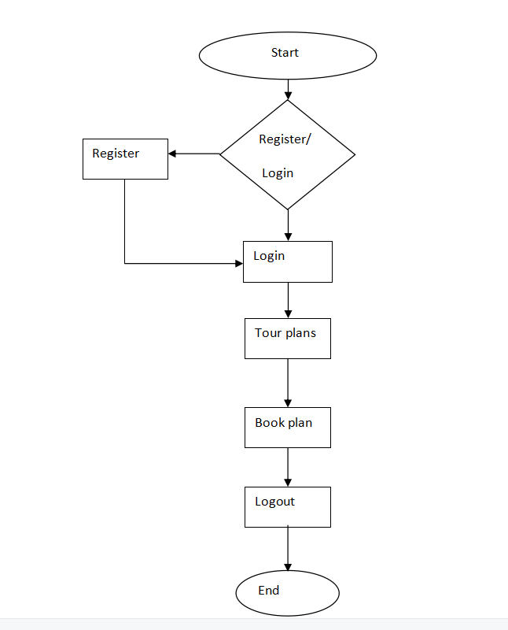

**SNAPSHOTS**

**LOGIN PAGE:**

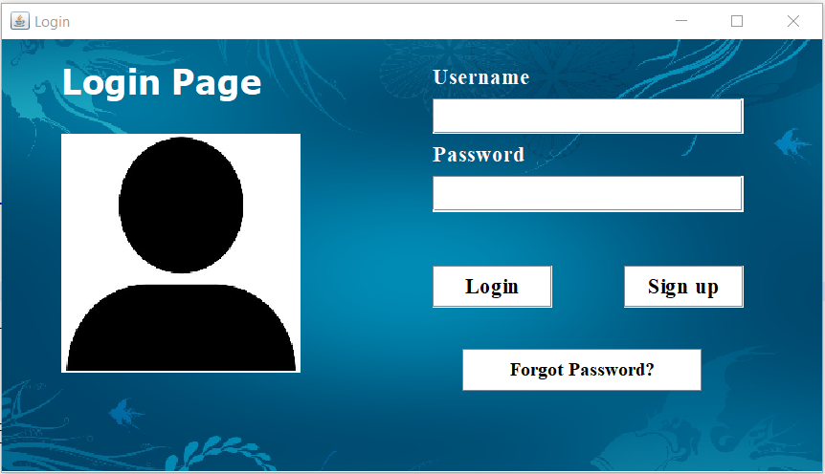

**LOADING PAGE:**

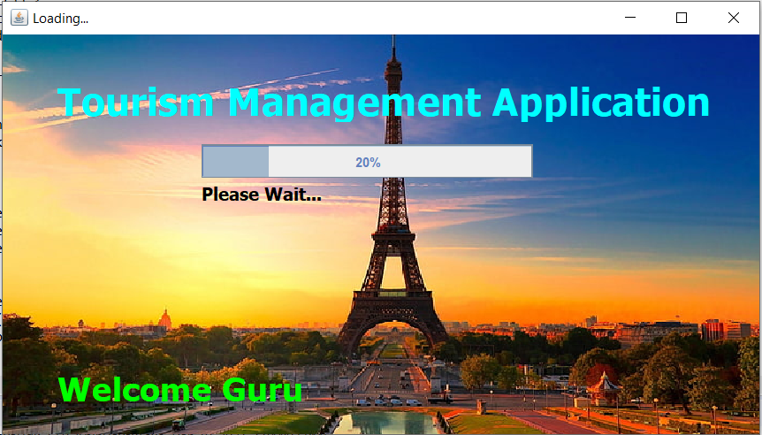

**MAIN FRAME:**

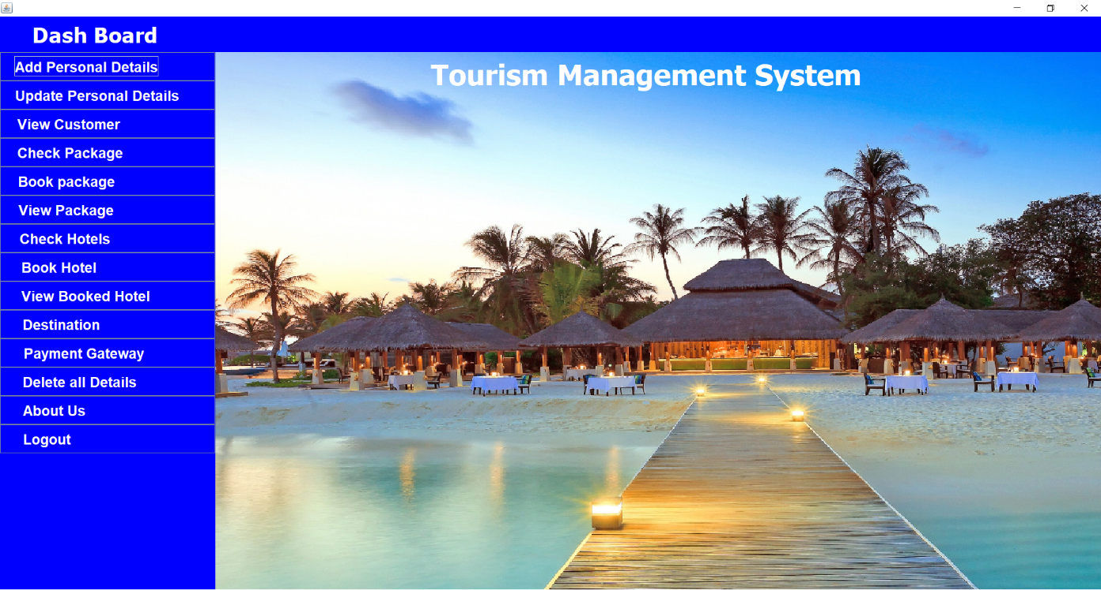

**PERSONAL DETAILS:**

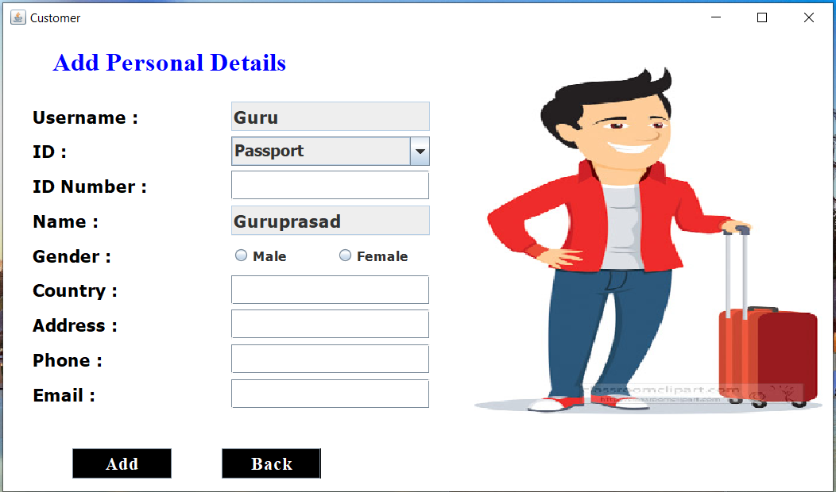

**VIEW CUSTOMER PAGE:**

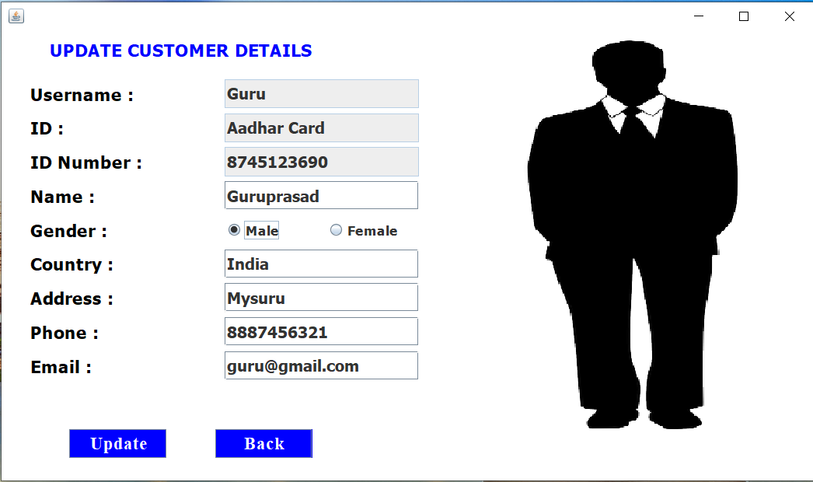

**VIEW CUSTOMER PAGE:**

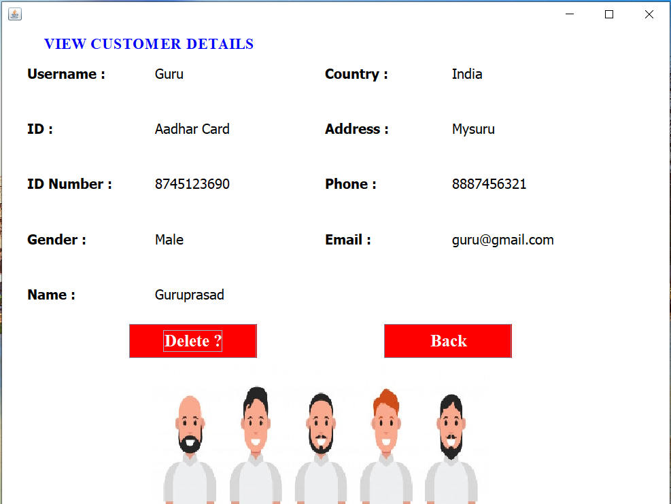

**PACKAGE PAGE:**

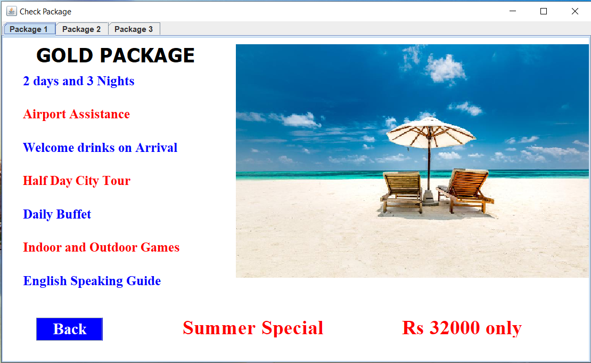

**BOOK PACKAGE:**

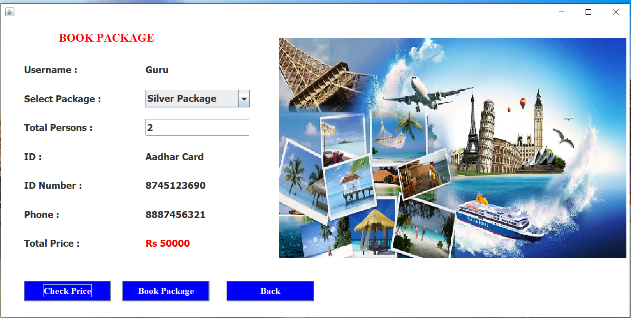

**VIEW PACKAGE:**

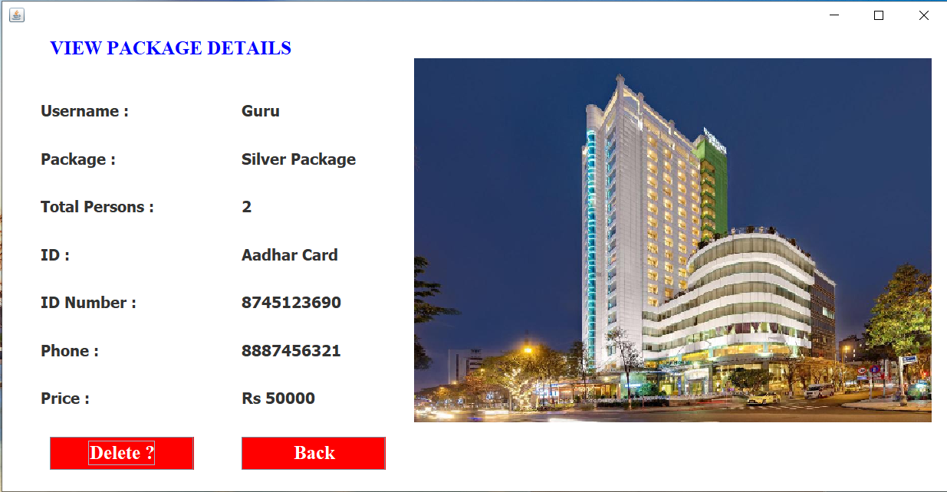

**BOOK HOTEL:**

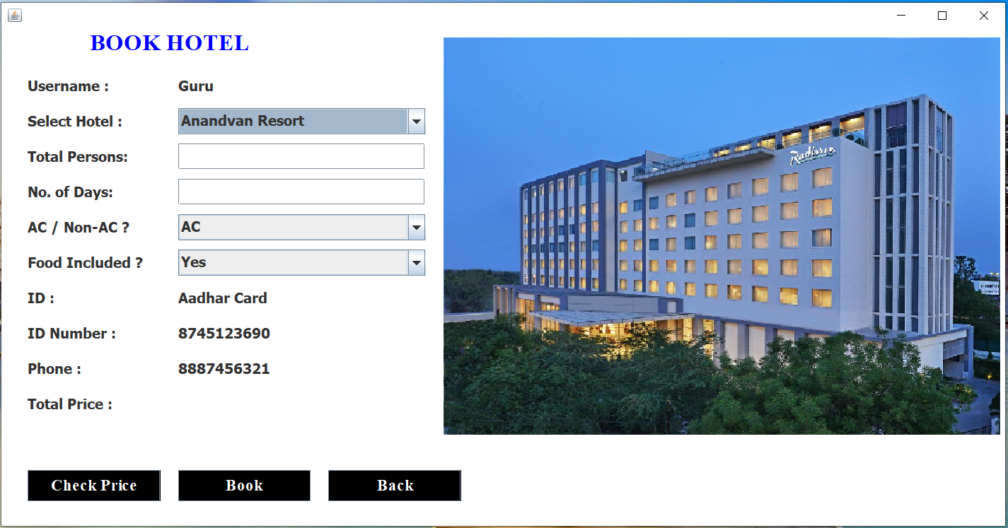

**VIEW HOTEL:**

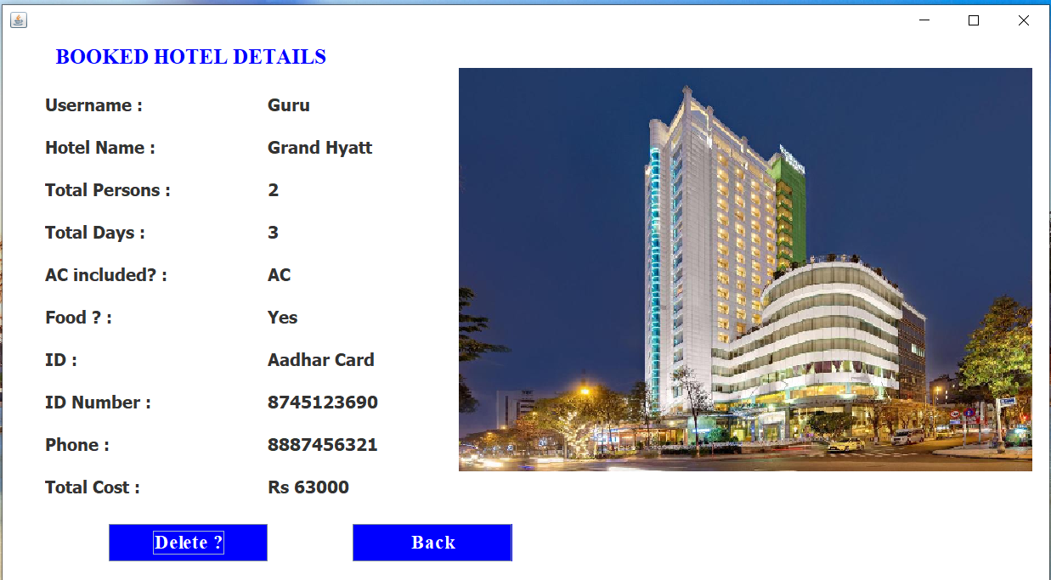

**DESTINATION PAGE:**

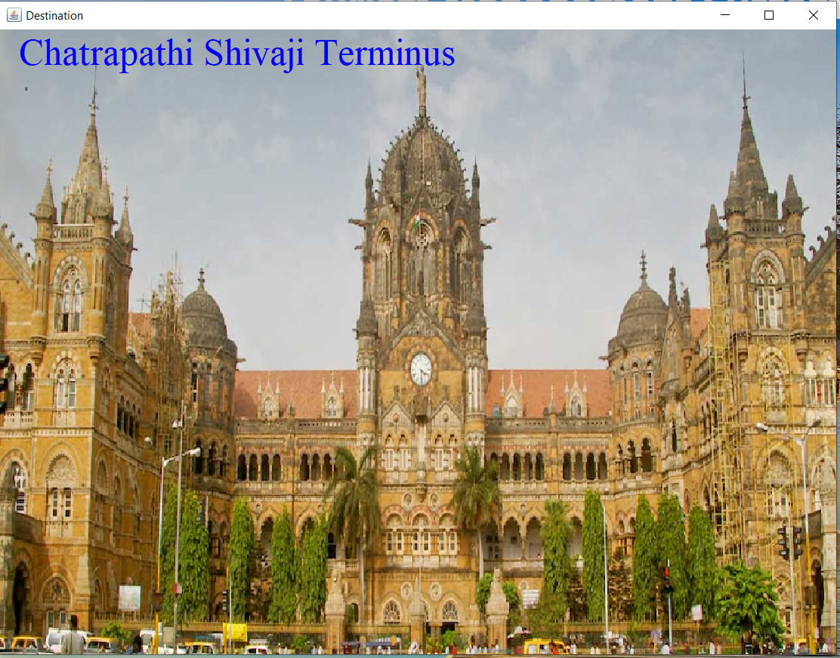

**PAYMENT:**

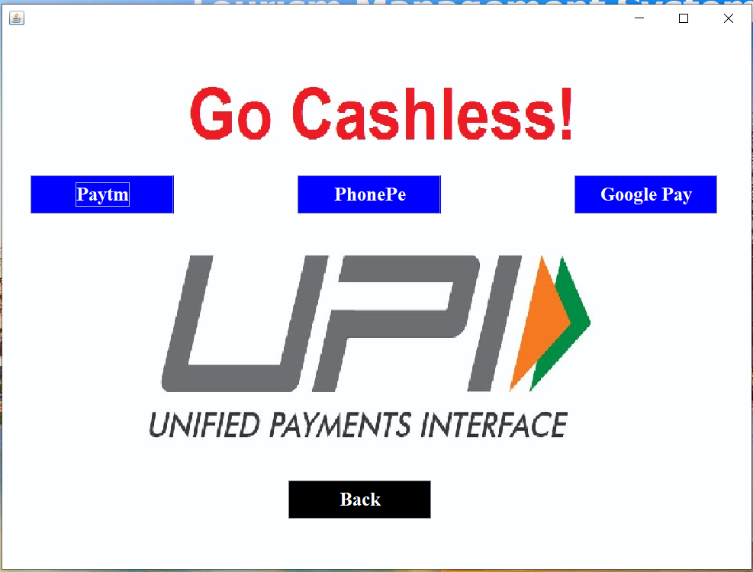

**DELETE ALL:**

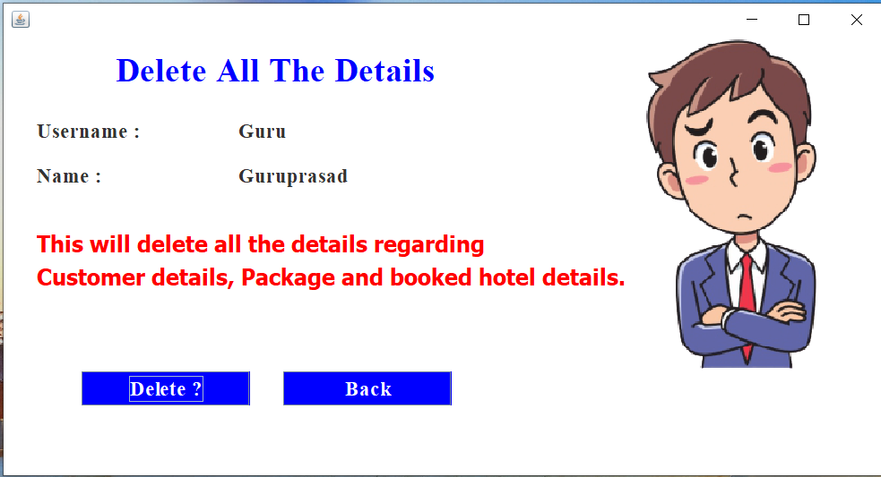

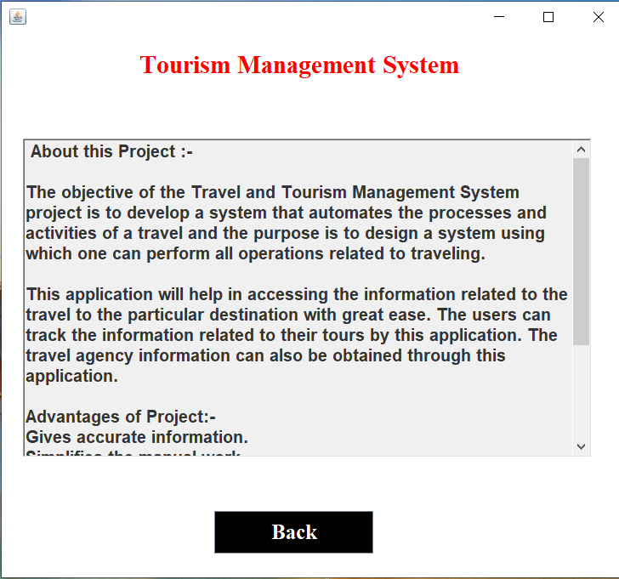

**CONCLUSION**

* **“**Tours and travel management system” simplifies the management process in travelling.
* Fast processing and immediate result with high security.
* Minimizing human effort and cost efficient database.
* Navigation through site is easy.

**REFERENCES**

We have taken references from many resources like YouTube and many websites.

Websites:

* <https://www.w3schools.com>
* <https://www.javatpoint.com>
* <https://www.codecademy.com>
* <https://www.stackoverflow.com>